**SAMPLE TEST SUMMARY REPORT**

**Introduction:** This summary report covers the verification the speed of web connection

**Test items:** Software product www.speedtest.net and www.speakeasy.net/speedtest .

**References:** Sample test plan, Sample test cases, Sample test results

**Test Summary**

1. **Test Case Information:**

**Test cases planned: 3**

**Test cases implemented: 3**

**Test cases executed: 3**

**Test cases passed: 3**

**Test cases failed: 0**

**Test cases pending: 0**

1. **Defect Report Information:**

**Total defects found: 0**

**Defects found in functional test: 0**

**Defects found in regression test cycle 1: 0**

**Defects found in regression test cycle 2: 0**

1. **Normal web connection**

**Download Speed:** 28847 kbps (3605.9 KB/sec transfer rate)  
 **Upload Speed:** 4856 kbps (607 KB/sec transfer rate)

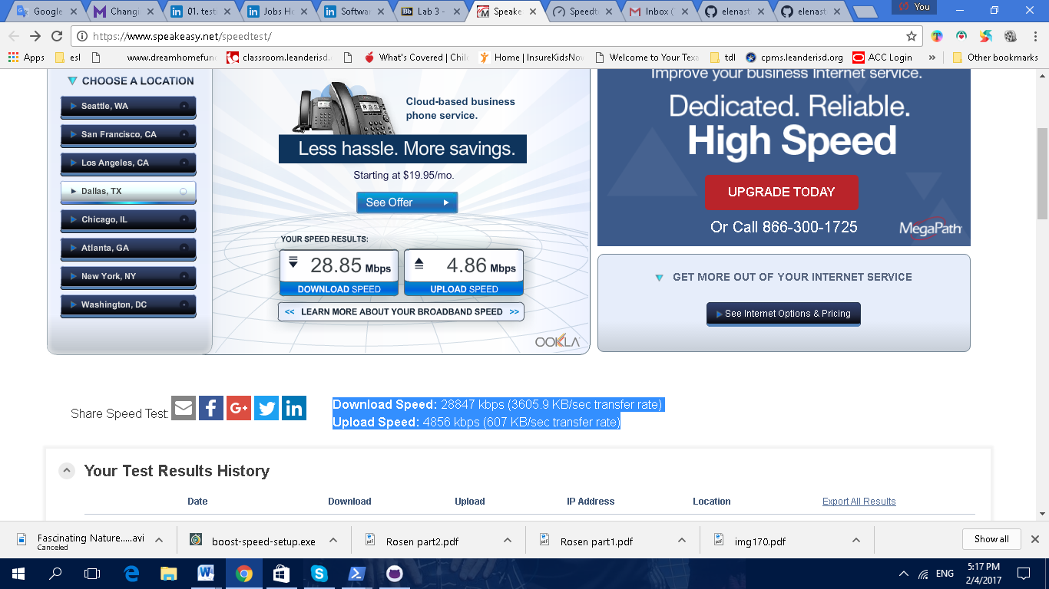

<http://www.speedtest.net/my-result/6026115369>

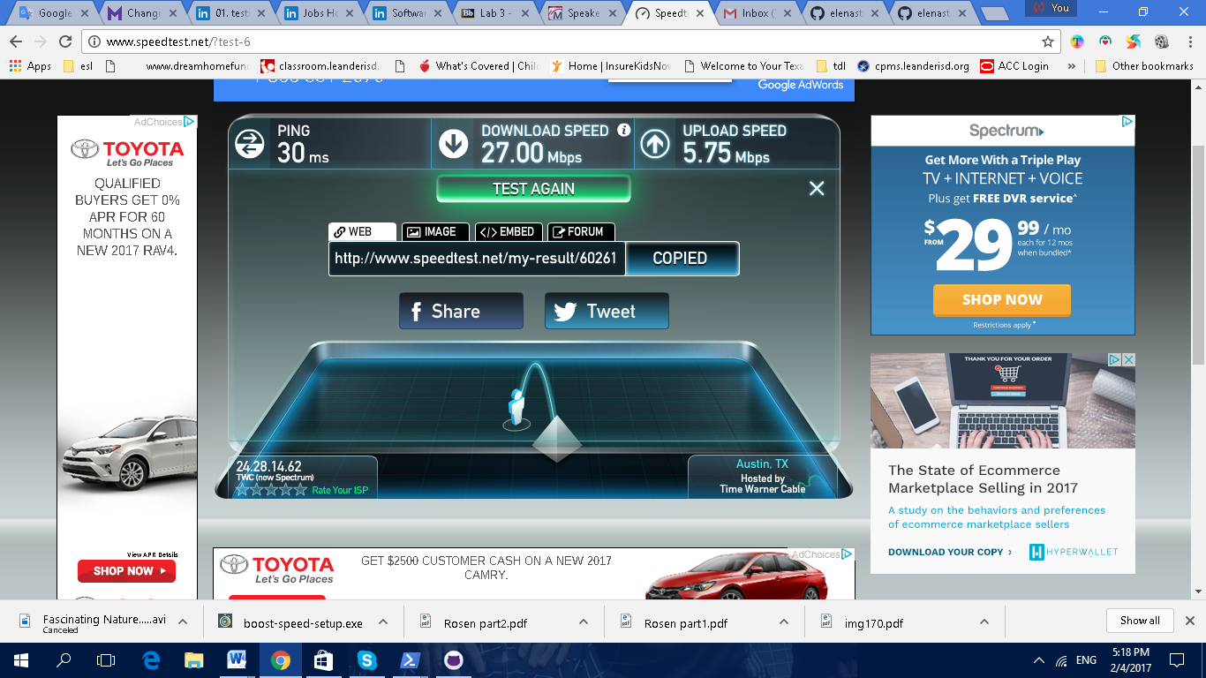

1. **Web connection-listening to music and downloading video**

**Download Speed:** 11706 kbps (1463.3 KB/sec transfer rate)  
**Upload Speed:** 4081 kbps (510.1 KB/sec transfer rate)

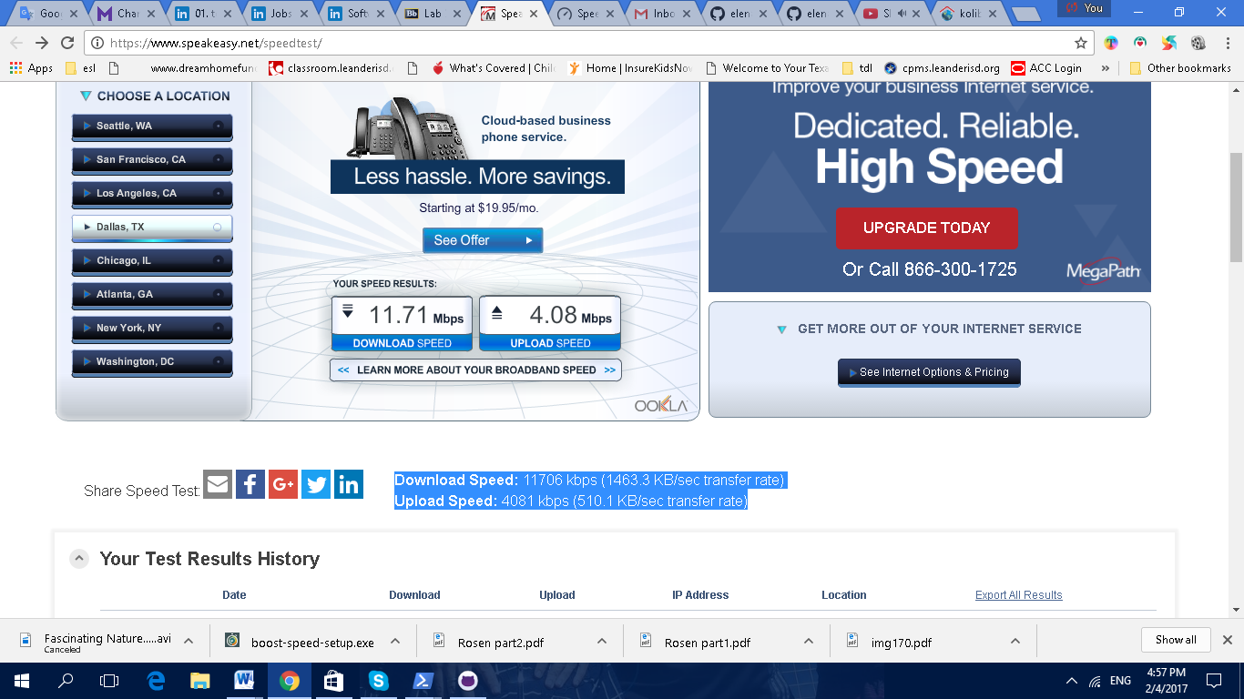

<http://www.speedtest.net/my-result/6026108766>

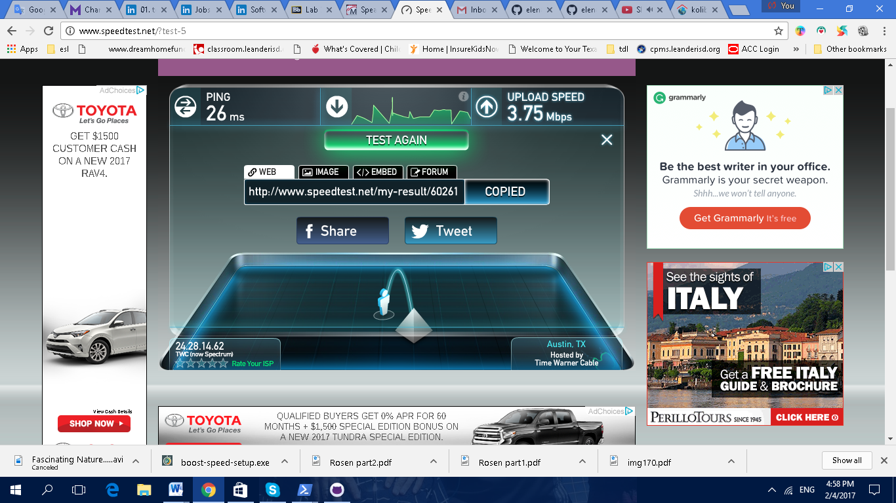

1. **Web connection-listening to music**

**Download Speed:** 27706 kbps (3463.3 KB/sec transfer rate)

**Upload Speed:** 4437 kbps (554.6 KB/sec transfer rate)

<http://www.speedtest.net/my-result/6026104924>

